**Overall Vision**

The Great Destruction ended the world. From the ashes, Imperalis rose as humanity’s last hope and began draining the planet’s resources for Project Exodus. With the directive to “save humanity”, the player will disembark into a postapocalyptic world equipped with a weapon that fires using energy gathered from sunlight or heat vents.

**Target Audience**

Any aged 16-20; Accessible for all with options for more challenging play

**Platform**

PC (Keyboard & Mouse)

**Genre**

Action-adventure platformer

**Core Gameplay**

**Core Mechanics:** The player is to explore Imperalis by running and jumping. Obtaining certain items will allow them to double-jump, dash, and cling to walls. The player can gather energy from various sources to shoot bullets: damaging enemies, destroying debris, or even powering certain objects. The player can experience the lore by talking to NPCs, reading item descriptions, or simply interacting with the world.

**Goals:** At the start of the game, the player is given the direcitve to “save humanity”. The directive will change twice, at 50% and 100% Data. In general, the player can save humanity by either following the Emperor or the Lost’s plan or freeing humanity. This results in three possible endings:

* **Save Humanity:** This ending requires the player to join the Emperor. The player will be sent into the Dreg Heap to capture the remaining Errats, fulfilling one of Project Exodus’ goals: to leave no human behind. With every Errat converted into Nadirs, Project Exodus can proceed as planned.
* **Free Humanity:** This ending requires the player to reject the Emperor. After defeating the Emperor, the player can choose to shut down the Ark and, with it, all of Imperalis and the Machina. This ceases the environmentally destructive Project Exodus and frees the Nadir. The planet’s recovery now falls into the hands of the humans.
* **End Humanity:** This ending requires the player to reject the Emperor and have 100% Data (collected throughout the game in secret locations). After the defeating the Emperor, the player can choose to blow up the Ark, killing the rest of humanity. Without the influence of humanity, the planet is guaranteed to recover though very slowly.

**Challenges:** To achieve any of these endings, the player must defeat bosses. In order to get to the bosses, the player may have to explore an area, solve puzzles, and defeat minor enemies. Getting hit by enemies or hazards will reduce the player’s health, killing the player if their health reaches 0. This will result in the player returning to the last repair station they interacted with. (**needs change**)

**Components:**

* **Stats:**
  + **Health:** How much damage the player can take before dying.
  + **Energy:** Used to fire bullets.
  + **Data:** The percentage of the Ego series the player has harvested.
    - **Harvest Locations:**
      * **Dreg Heap:** Injection Point, Rotten Depths
      * **Sunset Garden:** Upper Disposal Area, Garden Heights
      * **Twilight Town:** Far Station, Canopy
      * **Midnight Bay:** Stowaway
      * **Institute of Technology:** Lightning Hall
      * **Grey Palace:** Hidden Perch
      * **Frozen Sanctuary:** Edge of Humanity
* **Permanent Modifications:** Permanent upgrades. Which route they can be obtained on is labeled via the first letter of the route.
  + **Energy:**
    - **Solar Panel [S][F][E]:** Generates energy while the player is under **Beaming Light**. Obtained at the start of the game.
    - **Battery [S][F][E]:** Determines the player’s max energy capacity. Obtained at the start of the game.
      * **Extra Battery [F][E]:** Increases the player’s max energy capacity. There are three in total. Obtained after completing **Sunset Garden** and from **Twilight Town** or **Midnight Bay**.
    - **Geothermal Extractor [F][E]:** Generates energy while the player is above a **Heat Vent**. Obtained from **Sunset Garden.**
    - **Heartless Generator [F][E]:** Converts 1 health into 3 energy OR 5 energy into 1 health on use. Quick toggle for conversion change. Obtained from **Dreg Heap**.
  + **Mobility:**
    - **Booster Rocket [F][E]:** Allows the player to perform a horizontal dash. Dash is on a 3 second cooldown. Crafted from the first **Hyper Scrap**.
    - **Climbing Claws [F][E]:** Allows the player to cling to walls, resetting the player’s ability to jump (ex. jump > double > cling > jump > double). Crafted from the second **Hyper Scrap**.
    - **Booster Rocket MK2 [F][E]:** Allows the player to perform a second jump while midair (ex. jump > double or fall > double). Crafted from the third **Hyper Scrap**.
  + **Miscellaneous:**
    - **Special Plating [F][E]:** Increases the player’s max health. There are two in total. Obtained from **Sunset Garden** and **Grey Palace** after the returning to the **IT**.
    - **Energy Cannon [S][F][E]:** Used to shoot. Obtained at the start of the game.
    - **Navigational Module [F][E]:** Shows the map of Imperalis and the player’s current location, with areas the player already visited being visible. Obtained from **Dreg Heap**.
    - **Access Key [F][E]:** Allows the player to use the Vacuum Pod, granting access to the Midnight Bay. Obtained from **Twilight Town**.
* **Reactors:** Changes offensive capabilities. Only one can equipped at a time. The player can only swap reactors at repair stations. Which route they can be obtained on will be labeled via the first letter of the route.
  + **Basic Reactor [S][F][E]:** 1 (+1 per boss defeated) damage. 1 energy/shot. Starting item.
  + **Gentle Reactor [S]:** 0 damage. 1 energy/shot. Used to capture the Errat alive. Cannot be removed once equipped. Obtained from **Grey Palace**.
  + **Lost Reactor [F][E]:** 0 (+1 per 10% Data) damage. 2 energy/shot. Obtained from **Dreg Heap**.
  + **Unstable Reactor [S][F][E]:** 10 damage. 1 energy/shot. Bypasses all defense. Any damage taken will result in death (**Heartless** **Generator’s** health-energy conversion does not count). Obtained at the start of the game**.**
* **Interactable Objects:** Background objects that the player can interact with
  + **Repair Station:** Fully restores health and energy. Sets new spawn point. Allows player to swap their reactors. Respawns all enemies on use.
  + **Connecter:** 
    - **Active:** Takes player to another area when interacted with. Usually located in the background.
    - **Passive:** Takes player to another area when passed through. Usually located at the edges of an area.
  + **Destructible Block:** Shoot to destroy. Reveals useful or secret things.
  + **Beaming Light:** Light from above. Standing in it builds up **Energy.**
  + **Heat Vent:** Be it from the bottom of the ocean or in the steaming depths of steel, this is a prime source of energy. Standing above one with **Geothermal** **Extractor** builds up **Energy**.
* **Obstacles:** 
  + **Enemies:**
    - **Patrol Machina:**
      * **Behavior:** Travels back and forth between two fixed points. Deals contact damage.
      * **Stats:** 4 hp, 1 dmg / 8 hp, 2 dmg / 16 hp, 3 dmg
      * **Location(s):** Institute of Technology, Sunset Garden, Twilight Town, Midnight Bay, Grey Palace, Frozen Sanctuary
      * **Sprite:**  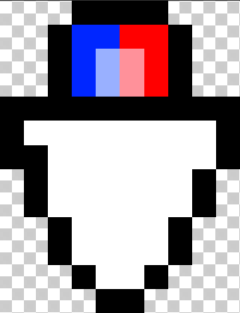      
    - **Pursuit Machina:**
      * **Behavior:** Travels back and forth between two fixed points. If player comes into view, it will chase the player. It will stop at walls and de-aggro if stopped for too long. Deals contact damage.
      * **Stats:** 3 hp, 2 dmg / 12 hp, 5 dmg
      * **Location(s):** Sunset Garden, Grey Palace
      * **Sprite:** 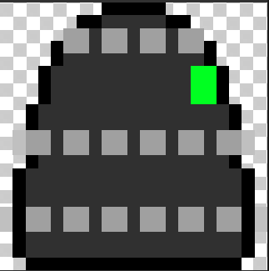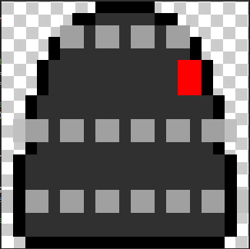
    - **Aerial Machina:**
      * **Behavior:** Can be either stationary or moving in a fixed pattern in the air. Will shoot at the player, dealing 1 dmg. Deals contact damage.
      * **Stats:** 6 hp, 2 dmg / 12 hp, 3 dmg
      * **Location(s):** Twilight Town, Grey Palace
      * **Sprite:** 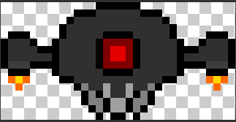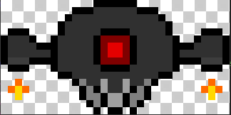
    - **Aquatic Machina:**
      * **Behavior:** Travels between two fixed points. If player is in range, it will aggro. Depending on the player’s vertical position relative to it, it will either swim up or down and begin shooting waves of 3 bullets (30 degrees from each other) at the player. If the player is is directly above or below its body, it will de-aggro. While not aggroed, it is invulnerable. Deals contact damage.
      * **Stats:** 10 hp, 2 dmg / 20 hp, 4 dmg
      * **Location(s):** Midnight Bay, Grey Palace
      * **Sprite:** 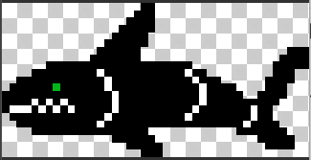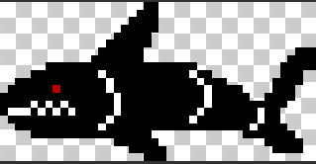
    - **Turret Machina:**
      * **Behavior:** Fires in a fixed direction or follows the player while they are in sight. While passive, scans back and forth a specific area. Deals no contact damage.
      * **Stats:** 20 hp, 3 dmg / 30 hp, 5 dmg
      * **Location(s):** Institute of Technology, Grey Palace
      * **Sprite:** 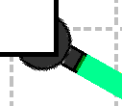 
  + **Hazards:**
    - **Toxic Sludge:**
      * **Behavior:** Deals contact damage.
      * **Stats:** 3 dmg
      * **Location(s):** Dreg Heap
      * **Sprite:** 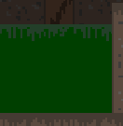 
    - **Super-heated Area:**
      * **Behavior:** Deals contact damage.
      * **Stats:** 5 dmg
      * **Location(s):** Sunset Garden, Grey Palace
      * **Sprite:** 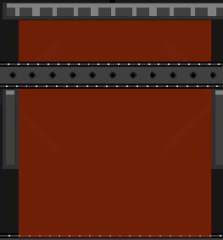
    - **Crusher:**
      * **Behavior:** Travels back and forth between two fixed points. Deals contact damage on the sides perpendicular to its movement.
      * **Stats:** 2 dmg
      * **Location(s):** Sunset Garden, Grey Palace
      * **Sprite:** 
    - **Electrical Line:** 
      * **Behavior:** Switches on/off after a fixed amount of time. While on, it deals contact damage and drains energy.
      * **Stats:** 5 dmg, 5 drain
      * **Location(s):** Institute of Technology, Grey Palace
      * **Sprite:** 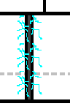
    - **Cutter:** 
      * **Behavior:** Either stationary or moving along a fixed path. Deals contact damage.
      * **Stats:** 10 dmg
      * **Location(s):** Grey Palace
      * **Sprite:**
  + **Bosses:**
    - **Overseer Machina:**
      * **Behavior:** Consists of three segments: top and bottom are treated as walls while the center segment is capable of dealing and receiving damage. Only two segments are on the screen at a time. The fight will open with a random attack, besides Scorched Earth.
        + **Mobility:**

**Gear Shift:** Shifts the boss up or down every 15 seconds so that the center segment is at the top or bottom of the screen. After shifting, a random attack will be performed after 1.5 seconds (1 second in Phase 2).

* + - * + **Attacks:**

**Ramping Fire:** Fires 10 consecutive bullets, dealing 1 dmg each. Fire rate increases after each bullet fired.

**Exploding Shot:** Fires a large bullet towards the player, dealing 4. When it hits the player or the outer box, it will split into 8 bullets traveling away from the epicenter in a circular pattern, dealing 1 dmg each.

**Scorched Earth:** After a 2-second warning, molten metal comes up and covers the ground. 8 seconds later, it goes back under the ground.

* + - * + **Special:**

**Charge Beam:** Charges for 5 seconds then unleashes a beam that is the segment’s height and the screen length in size, dealing 8 dmg. After its first usage, Phase 2 will begin.

* + - * **Stats:** 50 hp, 2 dmg
      * **Location(s):** Sunset Garden
      * **Sprite:** 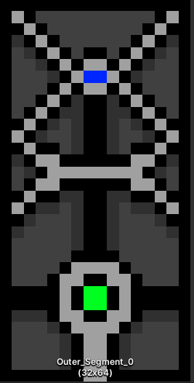 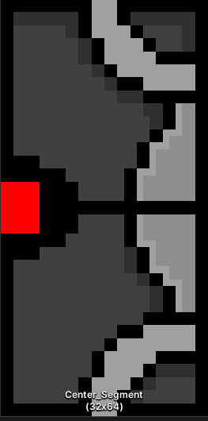 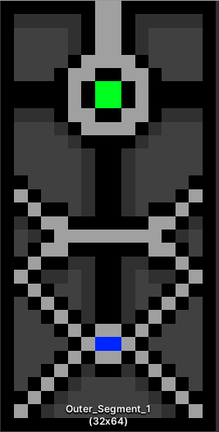
    - **Containment Machina:**
      * **Behavior:** Will chase after the player and is capable of moving freely through the air. Moves faster when the player is too far away. Deals contact damage.
        + **Mobility:**

**Blink:** Teleports some distance in front of where the player is moving. If the player isn’t move, teleport above the player. If the player is dashing, don’t teleport.

* + - * + **Attacks:**

**Crash:** Stops for 1 second (left eye flashing) then moves quickly towards the player in a straight line. Stops after hitting the player or the outer box. Rests for 2 seconds (1 second in phase 2) after stopping. Contact damage is doubled during this attack.

**Explosion:** Releases three waves of bullets, spread out in a circular pattern and traveling away from its center. There is 0.5 seconds between each wave and each bullet deals 2 damage. After the third wave, rest for 2 seconds (1 second in phase 2).

* + - * + **Special:**

**Berserk:** Stops for 1 second (right eye flashing) then begins. Perform a pseudo-Crash, but stopping only after hitting the outer box to perform a 1-wave Explosion. Repeat the Crash-Explosion combo two more times. Rest for 3 seconds after. Will only be used when under 60 hp (phase 2 threshhold).

* + - * **Stats:** 180 hp, 5 dmg
      * **Location(s):** Twilight Town
      * **Sprite:** 
        + 
        + 
    - **Subnautical Machina:**
      * **Behavior:** While underwater, it travels between two fixed points and takes half damage. While above water, it stays still. Deals contact damage.
        + **Mobility:**

**Dive/Surface/Leap:** Dive after 8 seconds above water or surface after 12 seconds underwater.In phase 2, instead of slowly surfacing, it can jump out of the water and land on the surface.

* + - * + **Attacks:**

**Surface:**

**Scatter Shot:** Fires 4 waves of 3 bullets (5 in phase 2) 30 degrees from each other (20 degrees in phase 2) towards the player with 0.5 second delay between each shot, dealing 2 dmg each. Rest for 2 second after.

**Underwater:**

**Crystal Barrage:** Fires 4 bullets (7 in phase 2) at the player, with 0.5 second delay between each shot (1.5 seconds delay between the 4th and 5th shots and 0.3 second delay during the second wave). Bullets 1-3 and 5-6 (3 dmg) split into 4 smaller bullets (circular spread) upon collision with the player or the outer box, dealing 1 dmg each. Bullets 4 and 7 are larger and will bounce off the outer box, dealing 5 dmg and splitting in to 8 smaller bullets (circular spread) after 5 bounces, dealing 2 dmg each. Rest for 2 second after.

**Torpedo:** Fires 3 homing bullets (5 in phase 2) at the player with 0.5 second delay between each shot, dealing 2 dmg each. The bullets can be destroyed by the player’s bullets. Rest for 2 seconds after.

* + - * + **Special:**

**Downpour:** Projectiles fall from the sky for 10 seconds, dealing 4 dmg each. Will only be used when under 100 hp (phase 2 threshold). Every 20 seconds during phase 2, there is a 2/3 chance for this to be used. When under 50 hp, the projectiles will twice as fast.

* + - * **Stats:** 200 hp, 4 dmg
      * **Location(s):** Midnight Bay
      * **Sprite:** 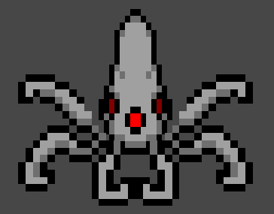
        + 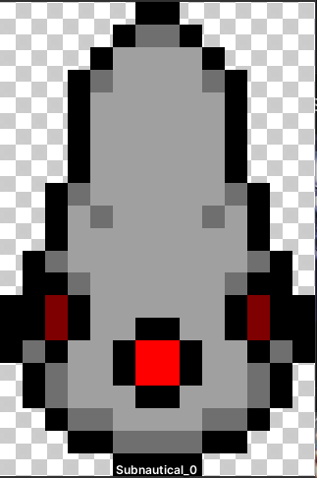 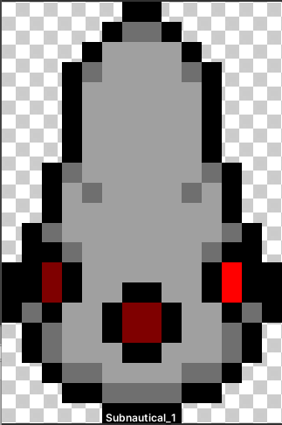 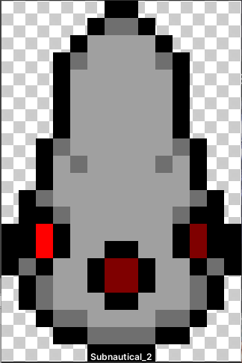
        + 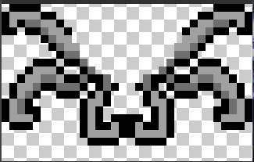 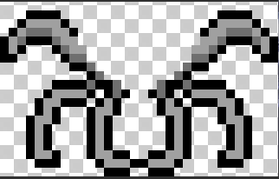
    - **The Emperor:**
      * **Behavior:** Chains three attacks then rests for 2 seconds. While attacking, he gains defense. Deals contact damage.
        + **Mobility:**

**Dash:** Moves rapidly towards the player, continuing until reaching the edge of the screen.

While in Desperation Mode, 4 projectiles will orbit the boss during the duration of the dash.

* + - * + **Attacks:**

**Alternating Fire:** Fires 4 bullets in rapid succession towards the player. Rests for 0.5 seconds. Fires 5 bullets in a cone spread. Rests for 0.5 seconds then repeats 2 more times.

While in Desperation Mode, the rapids are reduced to 2 bullets and the spreads are reduced to 3, however the rest periods are reduced to 0.25 seconds and the number of iterations is increased to 7.

**Energy Cannon:** Fires a large bullet towards the player. Rests for 2 seconds. After hitting the player or the environment, 8 bullets in an omnidirectional spread will fly from off-screen towards the collision area. These bullets pass through the environment and will only disappear after reaching the collision area.

While in Desperation Mode, fires 2 additional large bullets in a cone spread. Each will spawn the 8 omnidirectional bullets on collision.

**Return Shot:** During the rest period of any attack, the boss fire a projectile towards the player, returning to the boss after traveling a fixed distance.

While in Desperation Mode, the number of projectiles thrown during rest periods is increased to 3 and are fired in a cone spread.

* + - * + **Special:**

**Desperation:** Screen-length vertical beams, starting from the boss, travel across the screen in both horizontal directions. The beams travel top-to-bottom and can be blocked by the environment. On use, the boss enters Desperation Mode. Can only be used once.

**Struggle:** While in Desperation Mode, screen-length vertical beams, starting from the left and right screen bounds, travel towards the boss. The beams behave like those in Desperation.

* + - * **Stats:**
      * **Location(s):** Grey Palace
      * **Sprite:**
  + **Other:**
    - **Errat:**
      * **Behavior:** Does not move or deal damage. Can be talked to but capturing it requires having the **Gentle Reactor** equipped.
      * **Location(s):** Dreg Heap
      * **Sprite:** 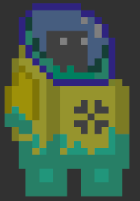
    - **Conveyor Belt:**
      * **Behavior:** Moves the player in a certain direction.
      * **Location(s):** Sunset Garden, Grey Palace
      * **Sprite:** 
    - **Water:**
      * **Behavior:** Slows the player down and reduces jump height and dash length.
      * **Location(s):** Midnight Bay, Grey Palace
      * **Sprite:** 

**Controls:**

* [a-key] hold: move left
* [a-key] double-release: dash left
* [d-key] hold: move right
* [d-key] double-release: dash right
* [w-key] press: interact with NPC or background objects (ex. repair stations, connecters)
* [s-key] press: use **Heartless Generato**r
* [f-key] press: switch **Heartless Generator** conversion
* [space-bar] press: jump / double jump if already in the air
* [tab-key] press: bring up / close the menu
* [mouse] move: move cursor
* [mouse-left] press: shoot

**User Experience:**

* **Starting:** The player begins in the main menu. Here they can start a new playthrough, look at the controls, or view their lack of trophies. Upon starting a new playthrough, the player will begin in **Origin** with the **Basic Reactor**. To the left is a wall that can be destroyed by shooting at it, revealing a room containing the **Unstable Reactor**. To the right is a locked door which can only be accessed near the end of the game. Further to the right are the **Solar Panel**, **Battery** and **Energy Cannon**. Picking up these items opens a way forward further right.
  + 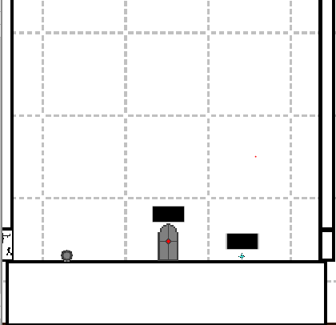
* **UI:** In the top-left section of the screen are health and energy values and the **Heartless** **Generator’s** current mode. In top-center section of the screen are icons which indicate whether the player is able to jump, dash or double-jump. In the top-right section of the screen is the name of the current area. The cursor is replaced by a red reticle which shows where the player is aiming. Pressing the [tab] button will bring up a menu where the player can access their inventory, the world map, and the controls, read lore, or save and exit to the main menu.
  + 
* **Structure:** While the overall layout of the world is quite linear, the individual levels are structured with a main path and optional sections. These sections may be accessible by destroying a tile, solving a puzzle, or having the right mobility upgrades. Or they may just be hidden behind objects closer to camera, being accessed by simply moving through. The player moves from one area to another by walking through passive connectors or interacting with active connectors. (**revamp needed**)
* **Map:**
  + 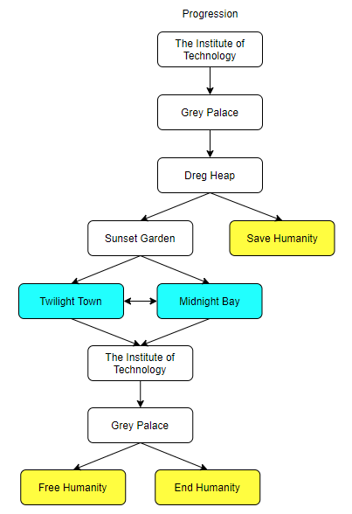
    - **Yellow:** Endings
    - **Cyan:** The player can complete these areas in any order
  + 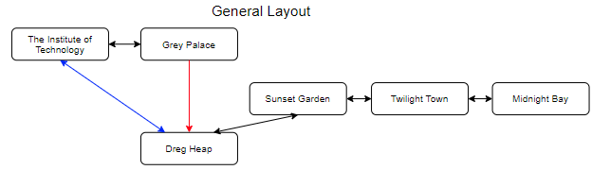
    - **Blue:** Only accessible with all three mobility upgrades
    - **Red:** One way

**Visual Style**

2D, simplistic pixel art, post-apocalyptic techno world

**Characters and Story**

* **General:**
  + 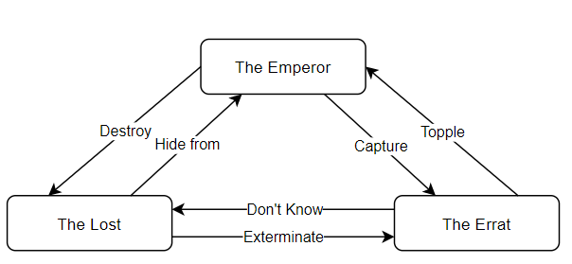
* **Characters:**
  + **Humans:**
    - **The Doctor:** An avid researcher in the realm of robotics, artificial intelligence, and cognitive science who designed the Machina. He aspired to become immortal by transferring his mind into a mechanical body. However, the Great Destruction and Project Exodus forced him to spend his time on more urgent things. Near the end of his life, he put himself in cryostasis within the Frozen Sanctuary, awaiting the day that he would be reawakened in a mechanical body.
    - **Azimuth:** Humans who have the ability to contribute to Project Exodus. In order to maximize productivity and prevent them from becoming Errats, they have been modified by the Emperor. When their skills are no longer needed, they are turned into Nadirs.
    - **Nadir:** Humans under cryostasis in the Frozen Sanctuary as they are considered unnecessary for the current state of Project Exodus. They consist of those who do not have the ability to contribute meaningfully to the project.
    - **Errat:** Humans who refused to be part of Project Exodus due to its freedom relinquishment. The Emperor believes they are making a mistake but cannot reach them in Dreg Heap.
  + **Machina:**
    - **The Egos:** The first and most difficult Machina to be built. The Doctor built them to come up with a plan to save humanity. However, they had differing beliefs.
      * **The Emperor:** It believed the planet was beyond recovery and that the only way to save humanity was Project Exodus. It is directly connected to the Ark, allowing it to control the Azimuth and Machina. Because of this, however, it cannot leave the Grey Palace. Defeating the Emperor allows the player to take control of the Ark.
      * **The Lost:** They believed that more information was needed before any decision was to be made. They left to explore the world and burrowed themselves all over Imperalis after exhausting their energy reserves in order to hide from the Emperor while still being able to be found by the player. Harvesting their memory drives, the player will discover their plan to eradicate humanity. They theorized that this Great Destruction was not the first and that humanity settled here from another planet as a result of something similar to the current Project Exodus. They believe that the Emperor’s plan is naive as it would only prolong their suffering and that the directive to “save humanity” should not be taken directly. Eradicating humanity would save them from their present and future suffering, the Lost’s ideal solution to the Doctor’s dilemma.
      * **The Player:** The player can decide to follow through with the Emperor or the Lost’s plan or free humanity and let them decide for themselves.
    - **Machina (Generic):** The machine residents of Imperalis, designed by the Doctor and commanded by the Emperor. The Machina help facilitate the construction, maintenance, and security of Imperalis. The Machina serve as the enemies throughout the game. Unlike the Egos who have specialized circuitry, these Machina cannot operate in Dreg Heap.
* **Events:**
  + **The Great Destruction:** A series of calamities which ended the world. From the ashes of the old world, Imperalis rose to shelter the survivors. The specifics of the Great Destruction are widely unknown though it possible.
  + **Creation of Ego:** In the midst of the Great Destruction, the Doctor built the Egos to come up with a plan to save humanity. The Ego now known as the Emperor believed that the planet could not be restored and that the best course of action would be to take what’s left of mankind and find another planet. The other Egos believed that more information was needed so they left to explore the world. When the world ended, these Egos did not return, resulting in the commencement of Project Exodus.
    - **The Failsafe:** Though he went forward with Project Exodus, the Doctor had some doubts about whether it was the best solution. He created another Ego that would activate if every other Ego besides the Emperor goes offline. This Ego’s decision to ally with or oppose the Emperor would determine the outcome of Project Exodus.
  + **Project Exodus:** The Emperor’s plan to save humanity consists of three goals: gather all remaining humans, extract the rest of the planet’s resources, and construct a spacecraft able to operate indefinitely.
    - Gathering the humans was a simple endeavor as Imperalis was seen as a beacon of hope following the Great Destruction. The humans were then implanted with a device that suppressed their free will and grouped into the Azimuth (those with the capacity to contribute to the project) and the Nadir (those who have nothing left to contribute to the project). This was to ensure maximum productivity-to-resource use. A small group of humans, however, did not trust not their future to the Machina and fled deep underground in the Dreg Heap. These humans, known as the Errat, are the top-priority targets.
    - The world was in ruin after the Great Destruction. The only resources left intact were those found deep underground and the seed bank far north. The Midnight Bay was constructed to extract these resources and carry them back to Imperalis. When the player awakens, the Midnight Bay has returned to the mainland after its final expedition.
    - In addition to attracting humans, Imperalis also served as the site of the Ark’s assembly. When the player awakens, the Ark has been built, fully equipped, and is ready to lift off.
* **Locations:**
  + **Imperalis:** What began as humanity’s last refuge following the Great Destruction became the launch complex for the Ark.
    - **The Institute of Technology (IT):** Imperalis’ center for research. It serves as the service structure for the Ark and is the only way to get onto the spacecraft from the rest of Imperalis. Though the Doctor is no longer around, the Azimuth and Machina still utilize this space.
    - **The Ark:** The largest space craft ever made. It serves as the vessel for humanity to survive in while they search for a new habitable planet. It has several nuclear reactors for stable energy generation in space, in addition to its vast supply of fossil fuels.
      * **Grey Palace:** The portion of the Ark jutting out from the ground. The Emperor commands the Machina and Azimuth from its peak.
      * **Frozen Sanctuary:** What’s left of humanity is put in a cryostasis here. Wildlife required to restart civilization is also cryogenically stored here. Though locked by a high-security gate, with at least 70% Data, the player can bypass it.
    - **Sunset Garden:** The Machina are recycled here when they can no longer function adequately. It also serves a recycling plant for any other resource including metals, plastics, and water. Any substance that cannot be reused or recycled is dumped into the Dreg Heap.
    - **Twilight Town:** The Azimuth and Machina can’t work indefinitely without maintenance. This place serves to repair and recharge the inhabitants of Imperalis. It also serves as the hub for the Vacuum Pods which allow for fast travel across Imperalis.
    - **Midnight Bay:** A massive multi-purpose construct the size of a city. It roams the seas, scouring the depths for any resource that could useful to Project Exodus, primarily being oil. During the events of the game, the platform has moved close to Imperalis, allowing the player to board it.
    - **Dreg Heap:** Existing deep underground, this place served as the dumping grounds for Imperalis’ waste. The Errat fled here due to its frigid and dusty environment which prevented non-Ego Machina from functioning.